1. Total count of the RoPA’s are 1470 in the MDS, but in the cube it is 2189.

Select

Count(distinct a.ID)

FROM png_mdsdb.pg_ot_ccpa_pa_inventory_c_final a where a.cdctype='X';

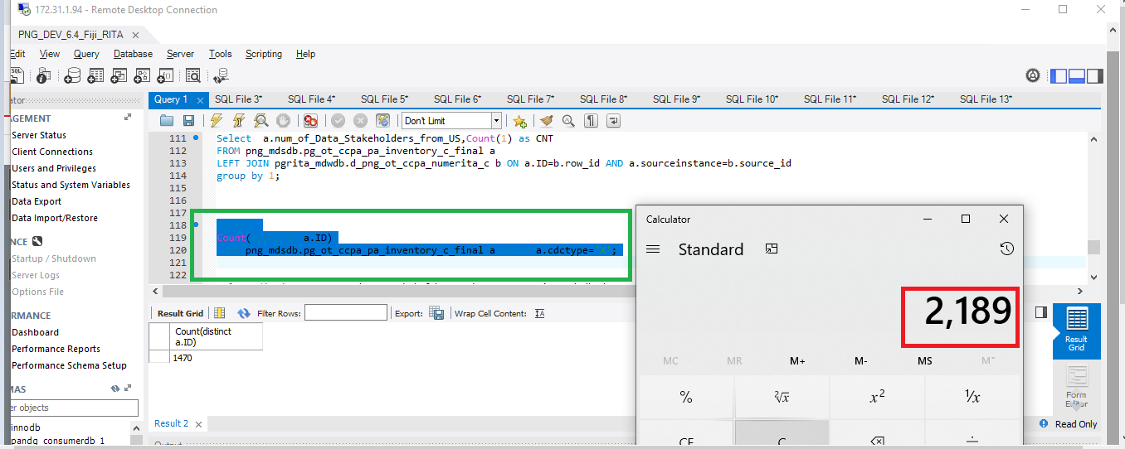

1. Life Cycle Status attribute is having UNKNOW and UNSPECIFIED and data is not matched with the CCPA RITA inventory_c cube.

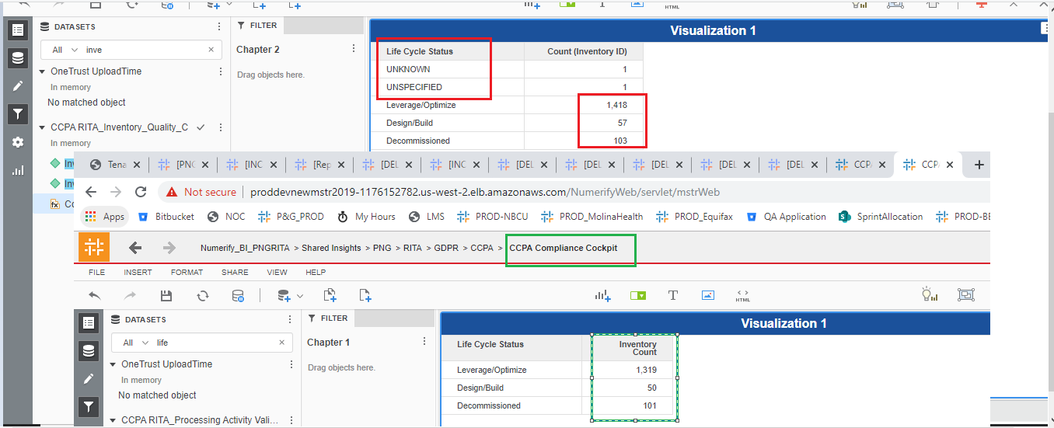

1. Minor Issues Is having UNKNOWN , UNSPECIFIED for the Same Inventories for the O Minor Issues. Functionality is not clear ?

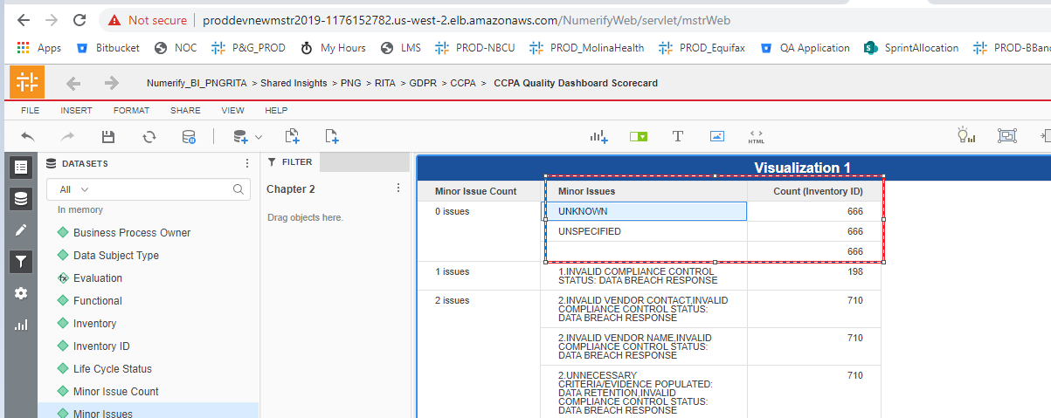

Same issues for the Vital issue count.

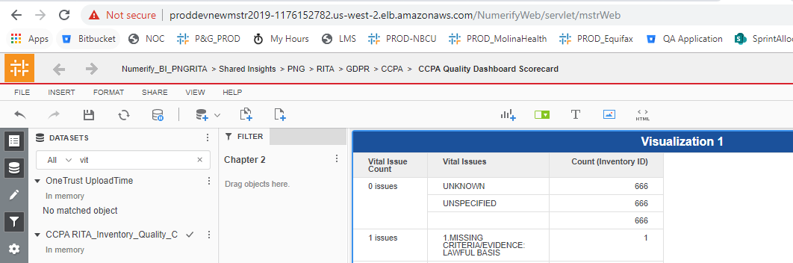

1. Data Subject Type Attribute is having UNSPECIFIED and UNKNOWN and data is not matched with the CCPA RITA inventory_c cube as the source is same for the both cubes.

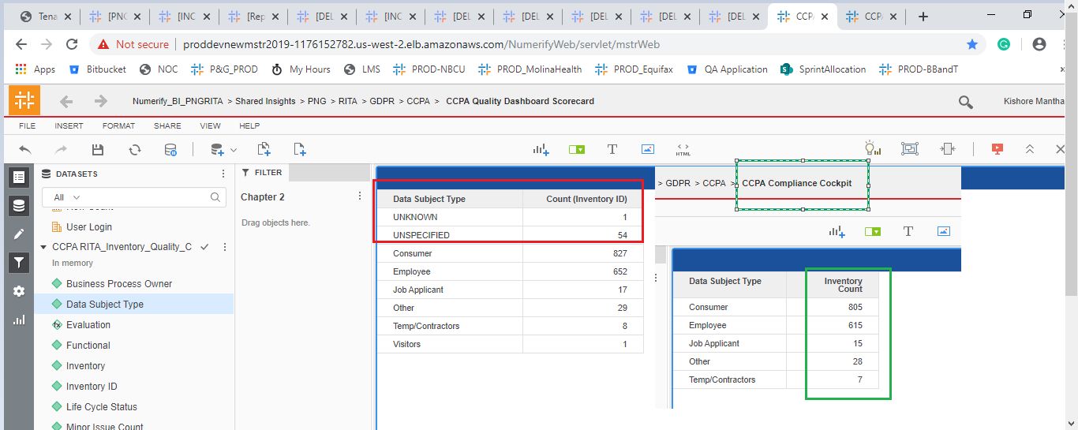

Same issue for the Function attribute :

